IE 411/511: Visual Programming for Industrial Applications
Fall 2015

Homework #2: Graphical User Interfaces

Due Date: By 2pm on Thursday, October 8th, 2015

PROBLEMS

All the problems shown below appear at the end of chapter two of your textbook “Visual Basic 2012: How to Program” by Deitel et al. (2012).

- (10 pts) Provide the answers to all questions in exercise 2.3 (page 54).

- When the ellipse button is clicked on the font property of your form/object a display box with additional font properties is displayed. (Font dialog popup window)
- F1
- GUI: Graphical-User-Interface
- The image property specifies which image a PictureBox displays.
- The View menu contains commands for arranging and displaying windows

- (10 pts) Provide the answers to all questions in exercise 2.4 (page 54). State whether each of the following is true or false and explain why.

  - True. You can add a control to a form by double clicking its control icon in the toolbox. This is the primary way to add any type of object. The double-click is essential because it stops you from accidentally adding objects while browsing.

  - False. No the form, label, and picture box have different properties.
    - For example, form and picture box both have background image as a property, label does not.
    - Additionally, another example would be that the form does not have a border style property while label and picture box do.

  - True. Yes you can browse the web from visual studio. The keyboard shortcut for this is ctrl-alt-R or alternatively you can go to view → other windows → Web Browser. This is useful for web programmers or those who need to double check sources a lot while keeping a tidy work environment as it allows you to limit the amount of open applications you have at once.

  - False. Although there are many helpful tools for implementing features and objects in Visual Basic using Visual Studio, in order to have a complex app you are going to need to fine tune or write your own code. Relying on system-designed code is bulky and not flexible enough to satisfy the needs of clients.

  - False. Sizing handles are visible in design mode. During execution, they are not visible because you are seeing the rendered model of your form creation. Therefore, you cannot edit what you have created.

- (10 pts) Create the graphical user interface (GUI) for problem 2.10 (page 57). Make sure to adhere to the formatting directions provided in instructions a) to e).

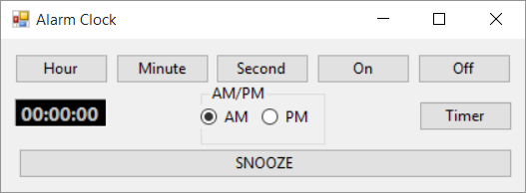

- (10 pts) Create the GUI for problem 2.11 (page 58). Make sure to adhere to the formatting directions provided in instructions a) to g). The image necessary to complete the GUI for this problem can be downloaded from the course’s web site.

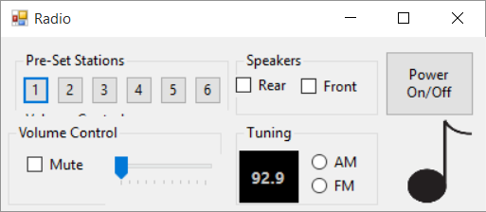
IE 411/511: Visual Programming for Industrial Applications
Fall 2015

Homework #2: Graphical User Interfaces

Submit a hard-copy of this page only at the beginning of the lecture session on

Thursday, October 8th, 2015

Student Name: Vladimir Predovic

TA Notes:

